

**Group Members:**

|  |  |
| --- | --- |
| Mostafa Walid | 230664 |
| Mohamed Waleed | 230663 |
| Abdelrahman Hossam | 235091 |
| Ahmed Hossam | 230620 |
| Kamal Ismail | 238138 |
| Ziad Ahmed | 229491 |
| Mohamed Hesham | 232042 |

**Group Number: 30**

Game Name: Broken Brotherhood

# **2.0: GAME Overview:**



**2.1: Game Genre:** Action

**2.2: Target Audience:** Males Aged 12+

**3. Dramatic elements of the game:**

**3.1 Characters:**

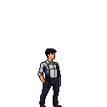  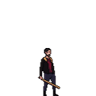

**Max (Main charcter) Rico(Boss) Leo(Lockpicker)**

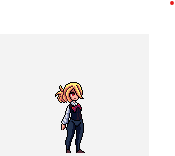

**Jack(the muscle) Vince(tech expert) Sarah(Max’s wife)**

**  **

**Mark(max’s son) Enemy1 Enemy2**

 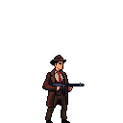

**Enemy3(the fastest) Enemy4 (the hardest)**

**- Max:** The main character of the game, a previous and very important member of the gang who decided to leave the gang after the birth of his son and the death of his wife (Sarah).

- **Rico**: The main enemy in the game, Rico was the boss of the gang that Max was member in, he was known to be ruthless and every one followed his orders. After Max’s decision to leave the gang, Rico was so frusturated as the gang started to fail in a lot of their missions and heists. Rico decided to kidnapp Max’s son to force him to work with the gang again.

- **Leo**: One of the enemies in the game that Max will have to defeat to get closer to his son’s location, Leo was a very skilled lockpicker that was able to unlock any obstcale that includes a lock (Doors, Safes, etc.).

- **Jack**: One of the enemies in the game that Max will have to defeat to get closer to his son’s location, Jack was known to be the strongest member in the gang and he was the one that had the most strength.

- **Vince**: One of the enemies in the game that Max will have to know his son’s location, Vince was known to be the best tech expert. He was also the one who planned for the kidnapping of Max’s son.

- **Mark**: Mark is Max’s son, he gets kidnapped and Max tries to save him throughout the game.

- **Enemy 1, 2, 3, 4**: NPC’s whom will be in each level, the player will have to defeat them before he/she reaches the main enemy of the level, each one of them have different difficulty with different health and damage.

**Kindly note that we got the feedback from phase one regarding the pixelation of the characters, however we were unable to find better sprites for all of the characters, we as a group are still trying to look for better options so please note that the characters may be subject to change in case we found better sprites applicable to the game concept.**

**3.2 Detailed story:**

Once, there was a gang of five fearless outlaws, led by a man called Rico. Rico was the man every one feared. He was so ruthless and cunning. By his side was Max, he was Rico's loyal second-in-command. Max was the mastermind of the gang; he was responsible for the heists planning. Alongside them were Leo, the lockpicker, who could open any lock with ease and get the crew out of tight spots, Jack, the powerhouse, who was the muscle of the gang and the strongest one in it and Vince, the tech expert, who was the backbone of the gang’s technological operations and the mastermind behind their high-tech strategies. Together, they were unstoppable, pulling off exciting and perilous missions.

One day, everything changed. Max met a woman called Sarah who captured his heart, and soon they had a baby boy named Mark but tragically his wife passed away during the childbirth, leaving Mark with his father Max who was shattered but decided to leave behind his dangerous lifestyle to be there for his newborn son. He was so determined to be the best father he could and protect his child from the dark world he already knew too well. Max decided it was time to walk away from the gang and its lawless ways to start a new and fresh life with his newborn child Mark.

However, Rico wasn't satisfied when he heard what Max decided. He saw Max's decision as a betrayal as for him losing Max was more than losing a trusted ally. So, Rico made up his mind about preventing Max from walking away from the gang and concocted a cruel plan to force him to remain in the gang. He kidnapped little Mark and held him hostage demanding Max's return to the gang.

But Max was determined otherwise. Love and the will to save his son made him accept the most difficult mission of his lifetime and to face his old gang members and former allies to rescue his son, Mark. His journey would be long and dangerous, knowing fully that each of his former allies would stand in his way. And he knew that it was no longer just a mission, it was a battle for love and redemption.

Max began his journey by facing Leo, the lockpicker and once his closest ally, friend and who only knew where was his home. Hoping for help and corporation, Max showed up at Leo's house. But shortly, their meeting turned into a fight and Leo accused Max of betrayal. The fight was fierce but Max overpowered Leo forcing him to tell him vital information. Leo never knew where Mark was as he never approved of Rico's plan. Despite his resistance, Leo only told him that Jack, the powerhouse, might know where Mark was. So, with no time to lose, Max left Leo behind and headed to Jack's location, determined to find his son.

Max's next target was Jack, the powerhouse, who’s known for his strength and power. Max went to Jack's location, hoping that Jack might have the answers. Max faced resistance when he confronted him, and an aggressive fight broke out. Jack's strength was overwhelming as Max already knew. Each punch was shaking the ground beneath them but Max fought till the last ounce of strength he had left and finally managed to bring Jack to the ground. Jack then revealed the truth that he only followed Rico's orders and Vince was the one who planned the kidnapping, so he definitely knew where Mark was. Jack told him where was Vince located and Max's eyes hardened as he realized Vince and Rico were the real enemies.

Max then confronted Vince, knowing he was the mastermind behind the plan. The fight was intense as Max was unleashing all his anger. Vince fought back with every trick he had but Max's determination to save his son overpowered him until he managed to defeat Vince. Max demanded the location of Rico and his son. With a defeated look, Vince revealed the location where Rico held his son. Max wasted no time and set off immediately, knowing that this was the final confrontation he had to face. The ultimate showdown with Rico awaited him who was one day his boss and greatest ally.

Max reached the final location; he was so tired but at the same filled with anger and determination. He saw Rico who was looking to him with a cold eye and smiling a smug smile. Max knew that if he didn't defeat Rico, he would lose everything. Rico had always been the boss, the one in control. But now, it was Max who had the upper hand as he was driven by the love for his son and the betrayal that had shaped his every move. The fight was hard, Rico was ruthless and both used every and last ounce of strength to defeat each other.

Finally, Max knocked Rico to the ground. Max was filled with a mix of exhaustion and relief. Max rushed to his son and found him unharmed. Max immediately took him to his arms and didn’t look back as he left as he knew the nightmare was over.

**4. Formal elements:**

**4.1 Mechanics:**

**4.1.1 Player interaction pattern:**

**Combat Mechanics:** Player attacks enemies aiming to defeat them

**Collaboration**: Gang member and their allies team up to defeat the main character

**4.1.2 Goals:**

- Player’s main goal is to get his son back.

- Player’s his goal in each level is to get closer to his son’s location.

- Player has to defeat enemies and avoid traps to win each level.

**4.1.3. Rules:**

- Survive as long as possible and defeat all the enemies that the player will face throughout the levels.

- Player has three lives.

- Player returns to last checkpoint when a life is wasted.

- After the three lives are wasted, player loses.

- Health decreases when the player gets damaged which will lead to the player’s death eventually.

- Player gets damaged either from being hit by enemies or from different types of traps.

- Enemies are damaged by character and can die.

**4.1.4. Actions, including whatever switches and buttons used:**

- Walking: Player walks in both directions using “A” & “D” buttons

- Running: Player runs in both directions using “Left Arrow” & “Right Arrow” keys.

- Jump: Player can jump by using the space tab to avoid obstacles and run from enemies

- Punching: Player punches enemies to damage them and eventually kill them using “X” key.

**Kindly note that the specified keys for the actions may be subject to change.**

**Flowcharts:**

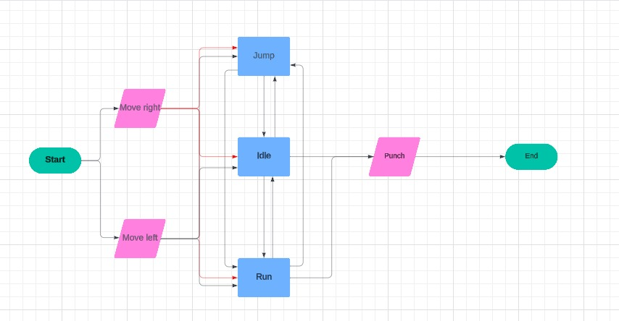

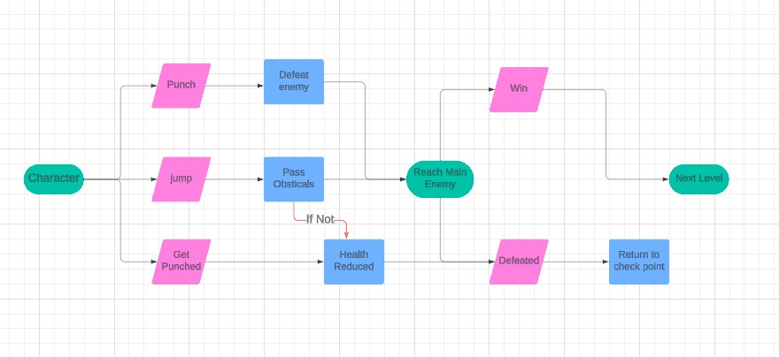

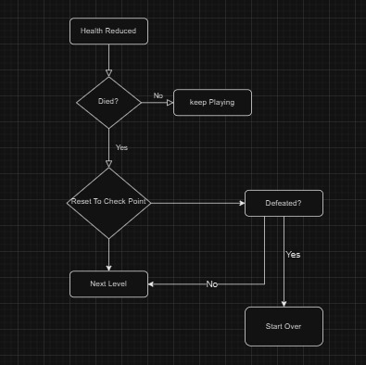

**Wireframes:**

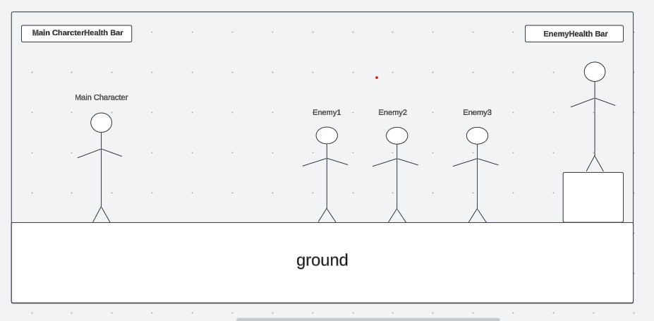

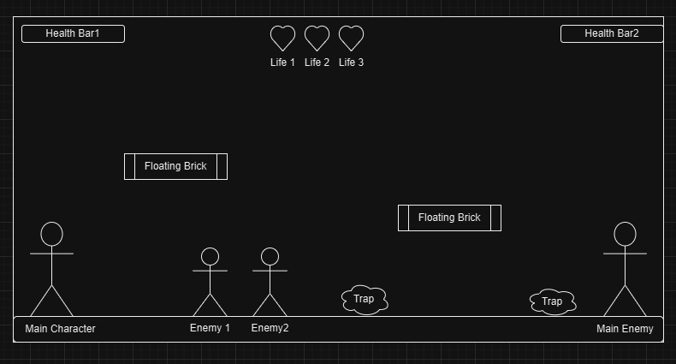

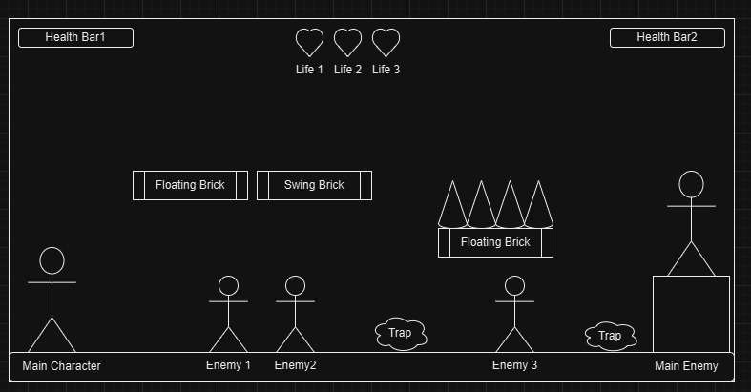

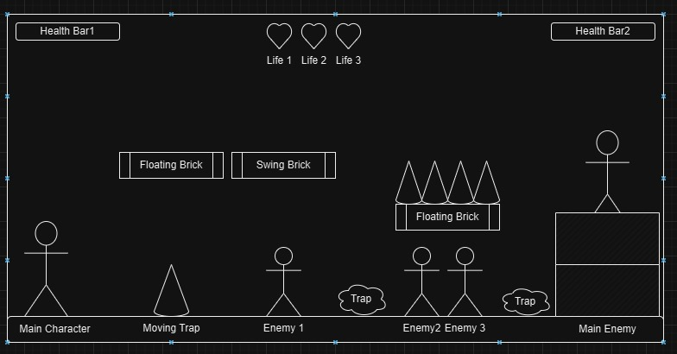

**4.1.5. Challenges:**

- Main Enemies at each level which are the gang members (Leo, Jack, Vince, Rico)

- Enemies that spawn at each level

- Different Traps that could cause damage to the player

**4.1.6. Resources:**

Player Health that decreases with enemy hits

Player attacks: Punching

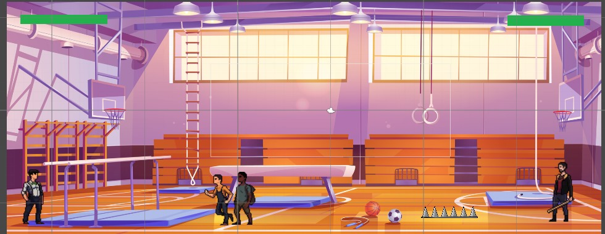

**5. Dynamic Elements**

**5.1: Sequence of Events:**

**Level 1: Confronting Leo**

Objective: Defeat Leo and his men to know where is Max’s son located.

Setting: Max enters the house of Leo, the lockpicker. The area is relatively straightforward, with no traps but there are enemies apart from Leo.

Enemy: Leo, though a skilled strategist, has normal health and normal damage

Enemies: Leo has a group of regular men who will try to stop Max, but they should not be difficult to defeat.

Challenges: The challenge here is facing Leo's men, who will try to stop Max from reaching Leo, but Leo himself should be more challenging.

Outcome: Max fights Leo’s men and eventually defeats Leo in a one-on-one battle. After Leo is defeated, Max learns from Leo that Leo never knew where was Max’s son location but Leo will tell Max about Jack’s gym location whom might know about Max’s son location.

**Level 2: Facing Jack**

Objective: Defeat Jack and his men, navigate through traps.

Setting: Max enters Jack’s gym. This level includes traps which are placed to damage Max.

Main Enemy: Jack; Jack is stronger and smarter than Leo, with greater health and stronger attacks. Jack’s specialty lies in his strength and the speed at which he strikes.

Enemies: Jack has a larger group of men who can cause more damage compared to Leo's men.

Challenges: In addition to Jack’s men, Max now must deal with traps that Jack has set to damage Max before Max reaches Jack. Max needs to stay alert and avoid these traps.

Outcome: After a difficult battle with Jack’s men and overcoming the traps, Max will fight Jack and should defeat him. After Jack is defeated, he will tell Max that Vince was the one who planned for the kidnap of Max’s son and that Vince should know the exact location for Rico and Max’s son. Max will learn from Jack about the location of Rico.

**Level 3: Battling Vince**

Objective: Defeat Vince and his powerful men, navigate a more dangerous battlefield.

Setting: Max enters Vince's lab, a heavily fortified location filled with even more dangerous traps.

Main Enemy: Vince, who is known to be very smart.

Enemies: Vince commands a much larger and stronger group men, all of whom are intent on stopping Max at all costs.

Challenges: The fight is much harder, with more traps and a greater number of enemies. Max must use his wits, speed, and strength to dodge traps while taking down Vince’s men. The physical confrontation with Vince is brutal, requiring Max to be strategic in his attacks.

Outcome: Max eventually defeats Vince after a long and punishing battle. With each victory, Max’s resolve grows stronger, and he moves closer to saving his son.

**Level 4: Final Showdown with Boss Rico**

Objective: Defeat Rico, reclaim Mark, and escape the criminal world.

Details:

Setting: Max enters Boss Rico’s hideout, the final and most dangerous level. The area is heavily guarded, with multiple traps and complex environmental hazards that will slow down and harm Max if he’s not careful.

Enemy: Rico is not only the most dangerous but also the smartest of Max's former comrades. He has far more health than any of the previous enemies and can make devastating damage with his attacks. Rico is also a skilled manipulator, using psychological warfare and tactical traps to weaken Max’s resolve.

Enemies: Rico commands an army of men—much more than Leo, Jack, or Vince. These men are more experienced and vicious, trying to prevent Max from reaching Rico. They have learned to anticipate Max’s tactics, making them more formidable.

Challenges: The combination of Rico’s strategic mind, deadly traps, and overwhelming number of enemies creates an almost impossible challenge for Max. However, Max's determination to save his son gives him the strength to push through. The battle is the toughest of his life, requiring Max to outsmart his enemies, avoid deadly traps, and take down the waves of enemies to finally face Rico.

Outcome: After an intense final battle, Max defeats Rico in a dramatic confrontation, reclaiming his son Mark. With the gang shattered, Max finally breaks free from the violent world he once knew. The victory signifies the end of his journey into the criminal underworld and the beginning of a new life for him and his son.

Conclusion: Max has completed his journey through the four levels, overcoming not just physical battles but emotional ones as well. With Mark safe and the gang defeated, Max has fulfilled his objective: he’s rescued his son and ended his past life of crime. The game concludes with Max walking away from the shadows of his past, ready to embrace a future full of hope, love, and redemption.

**5.2 Cut scenes:**

Cutscene (1):

Setting: Leo’s house

Cutscene Summary:

- After Max defeats Leo in a fight.

- Max tells Leo, “Now tell me! Where is my son!?”

- Leo replies, “I don’t know and I never knew where is your son”

- Leo, adds, “I never agreed with Rico’s plan to kidnap your son ... but Jack should know where they took your boy.”

- Max replies, “Where is Jack located now!!!?”

- Leo says, “This is Jack’s gym location.” (Max will learn where is the location of Jack’s gym and the game would move to the next level where Max should face Jack to know where his son is located).

Cutscene (2):

Setting: Jack’s gym

Cutscene Summary:

- After a fierce fight (concluded during gameplay)

- Jack confesses: “I’m sorry … I just followed orders.”

- Max replies: “I don’t care about your apology! ... I want to know where is my son located!”

- Jack says,” Vince planned it all. He’s the one you should be after”

- Jack adds, “This is the location of Vince’s tech. lab”

Cutscene (3):

Setting: Rico’s hideout

Cutscene Summary:

- After a brutal gameplay fight, the cutscene shows Rico defeated.

- Max finds Mark unharmed and embraces him.

- Rico says weakly, “You were always too soft, Max.”

- Max does not respond to Rico and takes his son and leaves.

- Overwhelmed with relief, Max embraces his son and whispers, “It’s over son. You’re safe now.”

- The final shot shows Max with Mark.

**5.3. ways for guiding and helping the players:**

- Text Prompts or Messages: It would help the player and remind him/her with a specific task or a specific button that does an action.

- Checkpoints: checkpoints should save the last position of the main character after the main character dies and this would help the player to get to his last location instead of starting the level from the beginning.

Audio files:

Main theme music for the game:   


Damage sound:



Jump sound:



Punch sound:



Steps sounds:



Game over sound:

<https://opengameart.org/content/lose-game-short-music-clip>

Final level sound:

<https://opengameart.org/content/finalbosslair>

**5.4. Outcome:**

Levels flow & outcomes:

First level outcome: Max defeats Leo, who provides information about Jack’s involvement.

Second level outcome: Max confronts Jack in a fierce battle. Jack reveals that Vince planned the kidnapping under Rico’s orders.

Third level outcome: Max faces Vince in his lab. After a hard-fought victory, Vince reveals Rico’s location and that Mark is being held captive there.

The game ending: After facing numerous enemies and traps before encountering Rico himself. The two engage in a brutal fight. After defeating Rico, Max saves his son successfully.

- Good ending: The game concludes with Max defeating his former boss, Rico, in the final battle, marking the end of his journey and his redemption arc. Max rushes to Mark and saves him and with that Max wins and achieves his goal.

- Bad Ending: If Max fails to defeat Rico or one of the gang members before his lives are wasted, the game ends and Max fails to save his son and so fails to achieve his goal